CrowSoft Sprint 5 Report

Liam Whorriskey

CSOFT Sprint 5 - Configure VMs - Prototype application

## Stories completed

* CSOFT-11   
  As a Developer, I would like to create prototype for application
* CSOFT-25   
  As a USER i want the ability to create an account SO THAT i can review building analysis
* CSOFT-38   
  Create VM to Host Staging Environment
* CSOFT-75   
  As Scrum master I want to add Components to JIRA to help identify which type of jobs/work is taking priority to the project.
* CSOFT-78   
  As a CrowsSoft Engineer, I would like to setup Gradle as a build tool connected to Artifactory, so that we can build and deploy packages in Artifactory to production
* CSOFT-87   
  As a CrowSoft Engineer, I would like to investigate SonarCube, so we can have a tool for code quality
* CSOFT-95   
  Issue with access control on Jenkins
* CSOFT-96   
  As CrowSoft engineer I would like start setting up the pipeline on Jenkins so that automated builds will run
* CSOFT-100 *   
  As a CrowSoft Engineer, I would like to create coding standards, so that we can all use the same coding standards

## Stories that where in progress

* CSOFT-54   
  As a CrowSoft engineer I WANT to deploy and test SELENIUM on our DEV server
* CSOFT-62   
  As CrowSoft Repository owner I would like to add webhook to github to allow Jenkins to trigger build
* CSOFT-97 As a CrowSoft Designer i would like to create a Graphic Mockup of the app SO THAT use steps have visual representation.

## Stories that did not start

* All started

## Moving Forward

Three incomplete stories carried to the next sprint.

## Burndown Chart

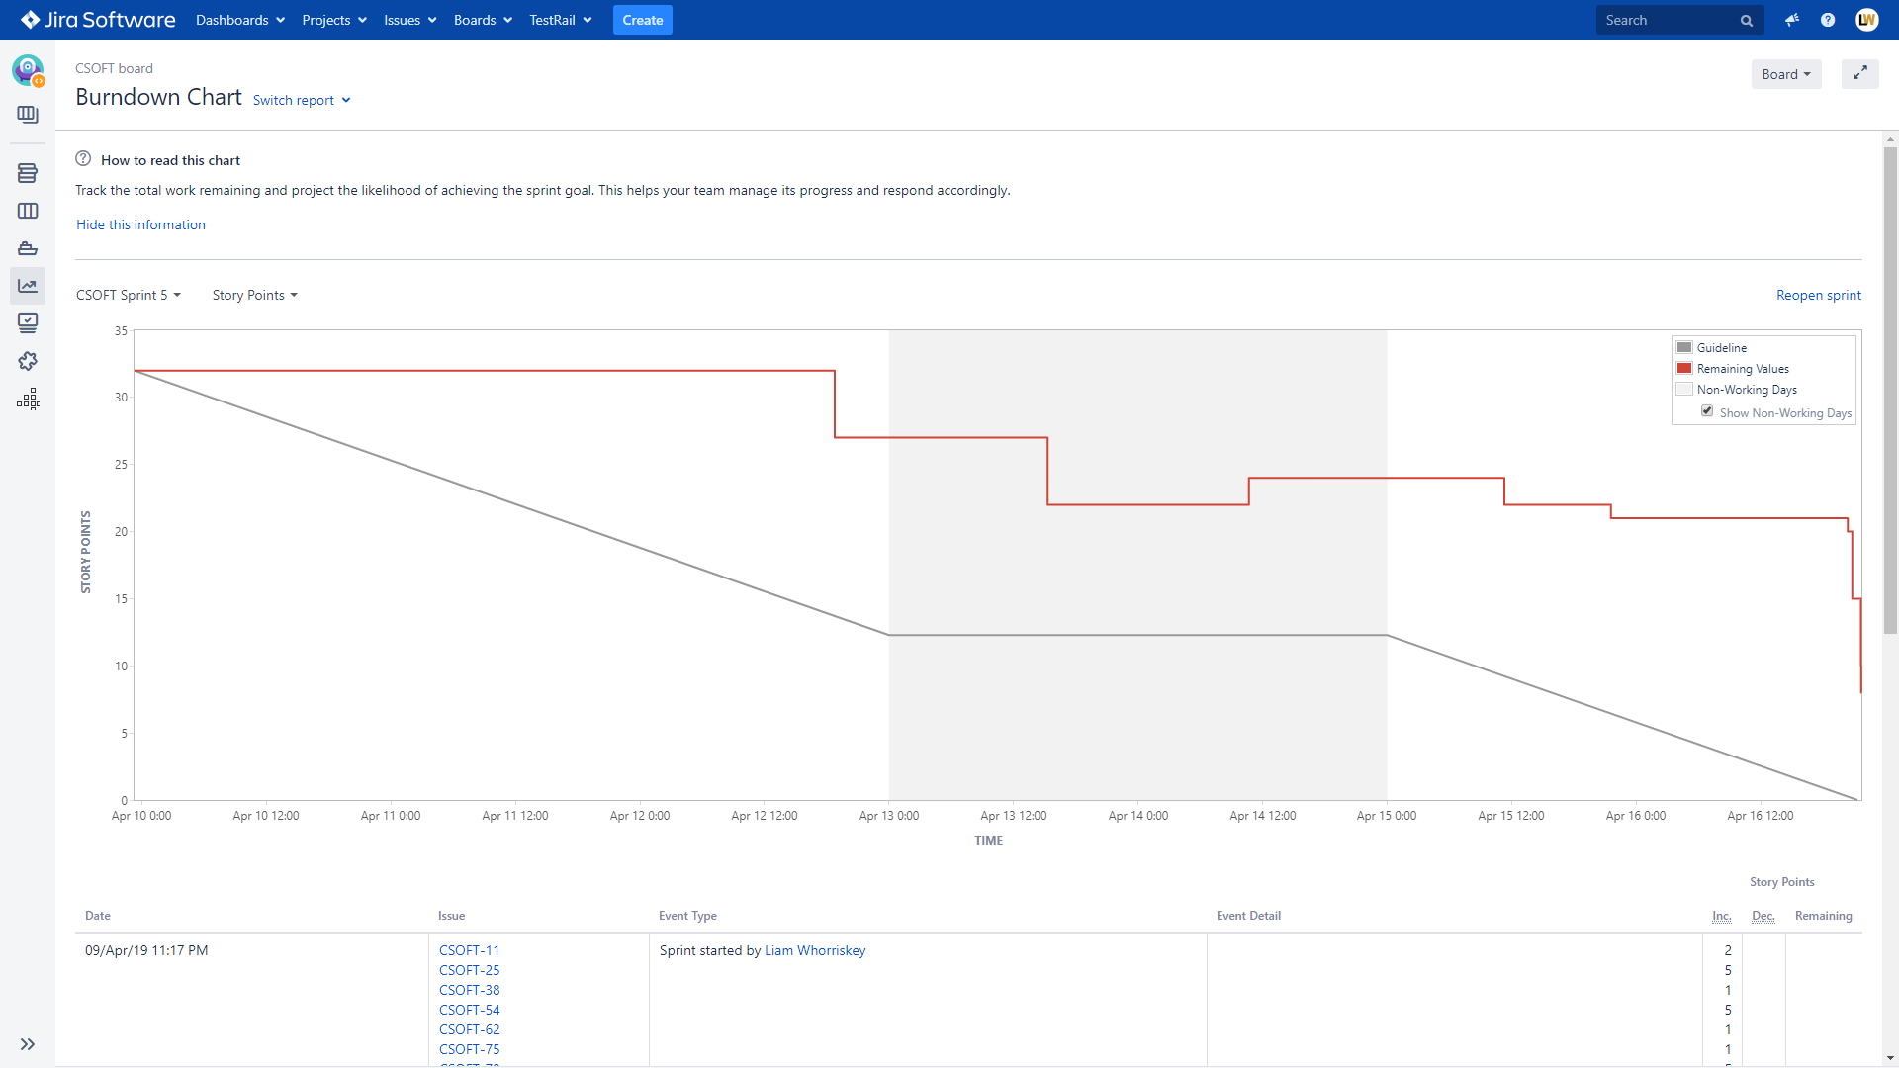

## Status report

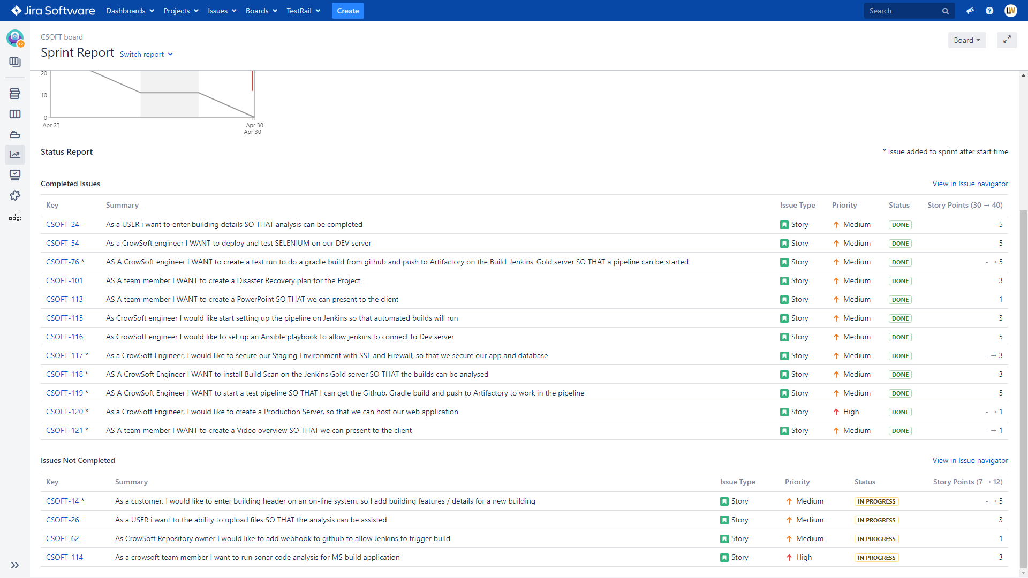

## Velocity Chart

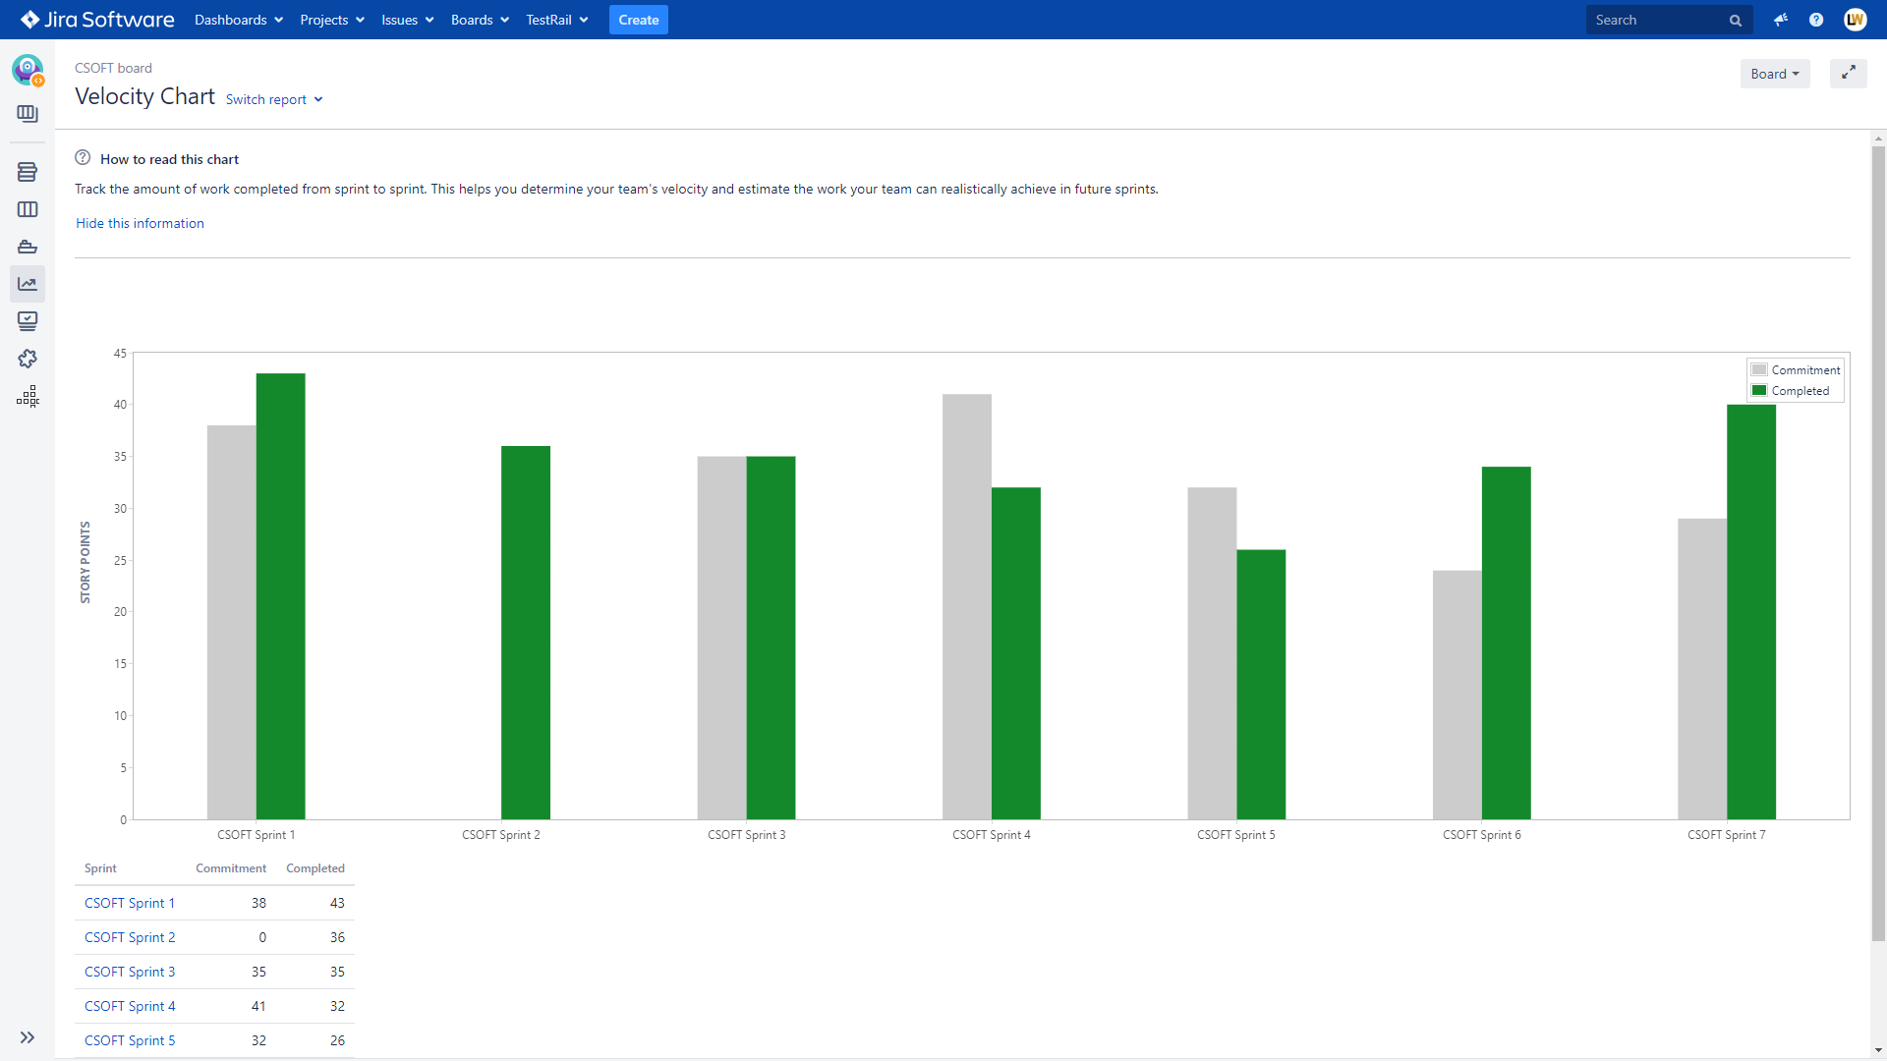

## Cumulative flow chart

